3. Add “tuned PPR” to the CV comparison that has been used for other methods. Use

the same folds as were used for the other methods. Arrange it so that in each fold, the

best PPR model is chosen exactly as above and is used to produce PPR’s predictions

for that fold. *This means that you will need to tune PPR exactly as in the previous*

*problem, separately within each fold!!! (You can use 5-fold CV for tuning if you want*

*to save a little time.* Separately save out the number of terms used in the best model

for each fold.



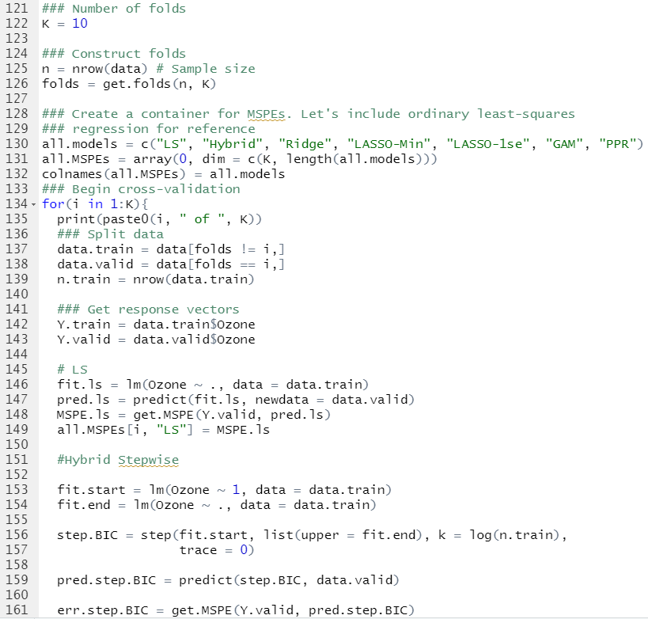

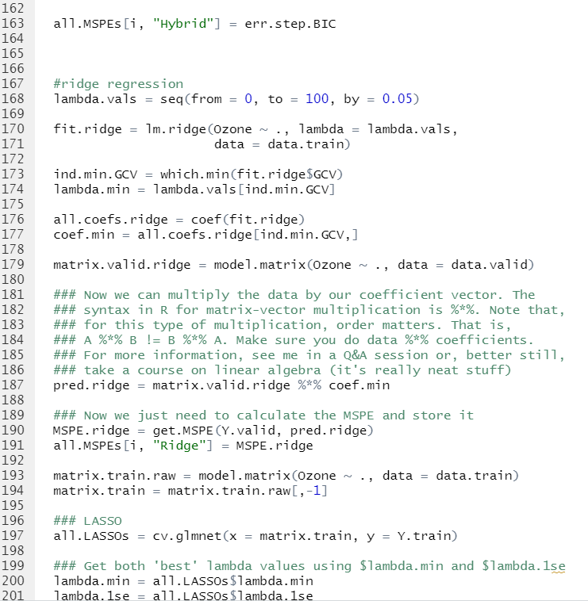

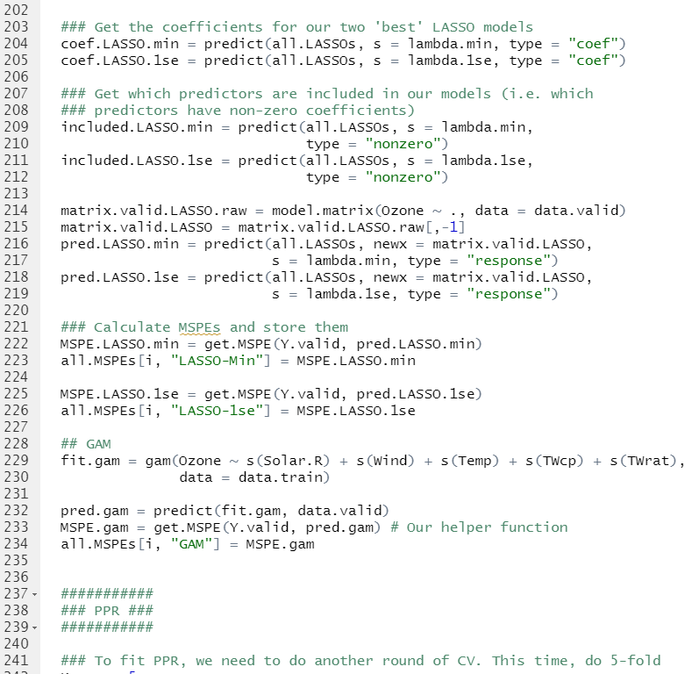

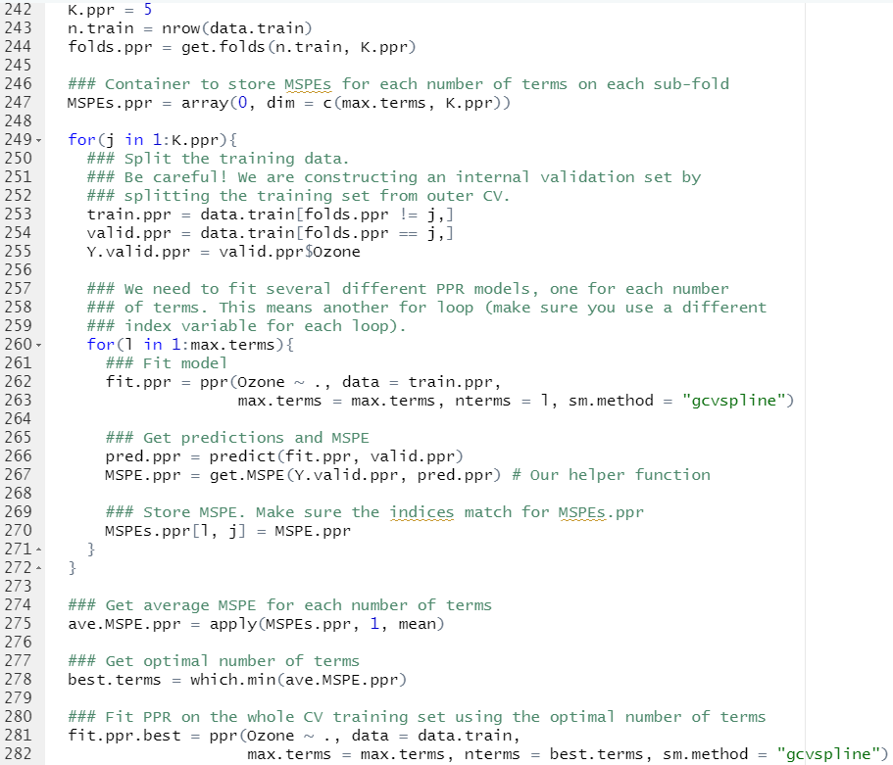

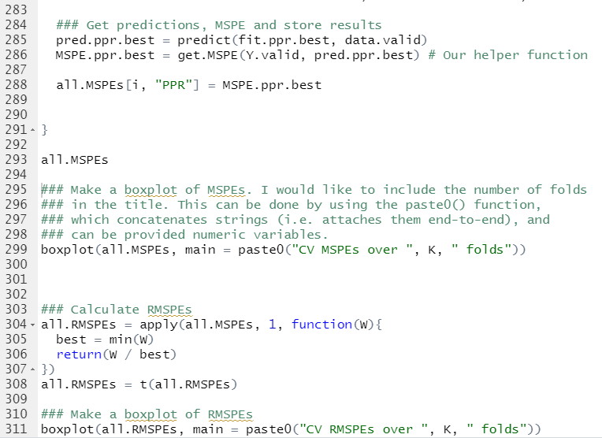

(a) **Add the tuned PPR to the boxplots. Present the plots and write a**

**sentence describing how well tuned PPR performs compared to other**

**methods we have used thus far.**

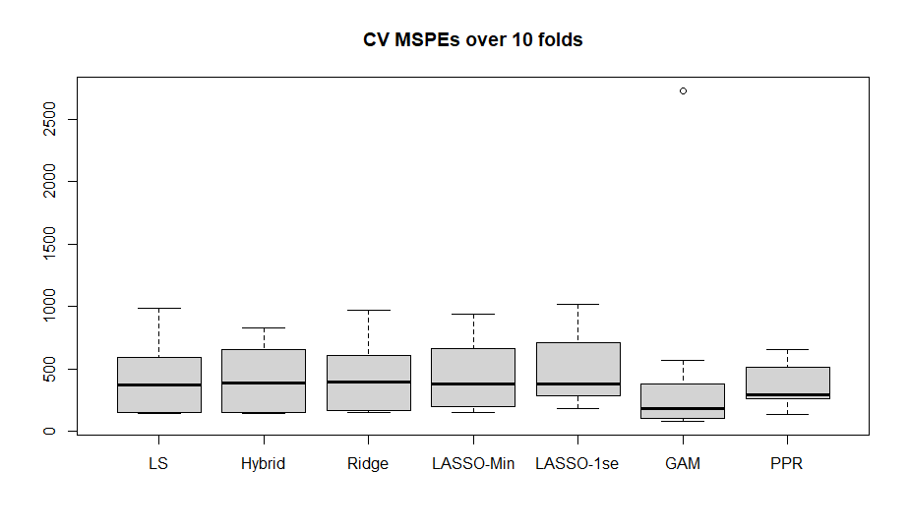

**->** It looks like PPR is better than LASSO and Hybrid.

(b) **Repeat this using relative MSPE.**

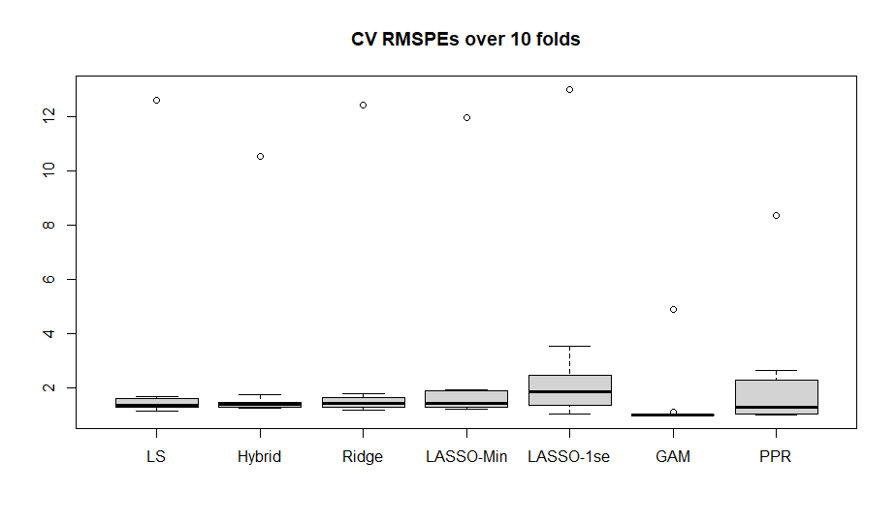

(c) **List the optimal tuning parameters that were selected for the tuned**

**PPR in each of the 10 folds**

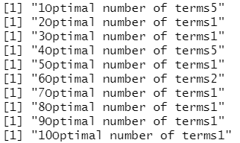

5, 1, 1, 5, 1, 2, 1, 1, 1, 1